

Production Test Plan
For VCS001

Product Name: IPEVO
Project Name: VCS001

Revision History
Rev | Description | Incorporated By | Approved by | Date
01 | Document created | Guozhou.Zheng | YanWu.Rao | 2022.08.09
02 | DVT1 Build Updated | Guozhou.Zheng | YanWu.Rao | 2022.12.02
03 | DVT1 Build Updated | Jingyuan.Chen | YanWu.Rao | 2023.01.06
04 | DVT1 Build Updated | Jingyuan.Chen | YanWu.Rao | 2023.02.15
05 | DVT2 Build Updated | Guozhou.Zheng | YanWu.Rao | 2023.03.21
06 | MP Build Updated | Jingyuan.Chen | YanWu.Rao | 2023.05.29

Table of Content
Production Procedure 7
Production procedure flow chart 8
Main Board Test Flow Chart 8
Audio_ Board Test Flow Chart 9
TOP Board Test Flow Chart 9
MIC FPC BOARD Test Flow Chart 10
Assembly Test Flow Chart 11
PACKING Test Flow Chart 12
T0.3 Test Station→Download Firmware (Main board) 13
Programming of MCU(GD32F310G8U6) 13
T0.3 test fixture block diagram and pictures 14
T1.1 Test Station → PCBA Electrical Function Test (MAIN BOARD) 14
PCBA Electrical Function Test 14
T1.1 test fixture block diagram and pictures 15
T1.2 Test Station →(Audio_board Electrical Test) 16
Audio board PCBA Electrical Test 16
T1.2 test fixture block diagram and pictures 17
T1.3 Test Station →( TOP Board Electrical Test) 18
TOP Board Electrical Test 18
T1.3 test fixture block diagram and pictures 19
T1.4 Test Station →( MIC FPC Board Test) 19
MIC FPC Board Test 19
T1.4 test fixture block diagram and pictures 20
T1.5Test DC Jack board PCBA Function Test 21
DC Jack board PCBA Function Test 21
T1.5 test fixture block diagram and pictures 21
T2.0 Test Station →( Speaker Pre-assy test) 22
T2.1 test fixture block diagram and pictures 23
T2.1 Test Station →( MIC Curve test) 24
MIC Curve test 24
T2.1 test fixture block diagram and pictures 25
T2.2 Test Station →( MIC Sealing test) 25
MIC Sealing test 25
T2.2 test fixture block diagram and pictures 27
T2.3 Test Station →( Sub Assembly Camera Test) 27
Sub Assembly Camera Test 27
T2.3 test fixture block diagram and pictures 31
T2.3-1 Test Station →( Sub Assembly Download calibration data) 31
Sub Assembly Download calibration data 31
T2.3-1 test fixture block diagram and pictures 32
T2.4 Test Station→( LED board test +key bottom test) 32
LED board test +key bottom test 32
T2.4 test fixture block diagram and pictures 33
T3.1 Test Station→( FG Function Tes) 34
FG Function Test 34
T3.1 test fixture block diagram and pictures 35
T3.2 Test Station→( Acoustic test of finished products) 35
Acoustic test of finished products 35
T3.2 test fixture block diagram and pictures 37
T3.4Test Station→( FG Camera Test) 37
FG Camera Test 37
T3.4 test fixture block diagram and pictures 40
T3.5 Test Station (FG Function Test(Listening,Camera) ) 41
FG Listening,Camera Test 41
T3.5 test fixture block diagram and pictures 42
T5.0 Test Station (FG Function Checked(Factory Reset,FW Checked) 42
FG Listening,Camera Test 42
T5.0 test fixture block diagram and pictures 43

Introduction
This document describes test plan for VCS001. All test points, pin numbers, signal names and allocation of components refer to the schematic drawing of“vcs0001-audio-rb_220701a.pdf”&“vcs001_mb_evt2_2206022.pdf” &“VCS001_TOP_DVT_220629_3”&“VCS001_MIC_FPC_MOLD__220527_01”The acronyms and abbreviations are defined as following：
HW | Hardware
SW | Software
DUT | Device Under the Test
ECI | Enhancement Control Interface
LAN | Local Area Network
UI | User Interface
GPIO | General Purpose Input/Output
FPH-3 | RS-232 To ECI Convertor
DMM | Digital Multi Meter
ASIC | Application Specific Integrated Circuit
TP/T | Test Point
PSU | Power Supply Unit
TS | Test Step
PCB | Printed Circuit Board
PCBA | PCB Assembled (components mounted on PCB)
ISP | In-System Programming
ASM | Assembly
BA | Bluetooth Address

Production Procedure
The following flow chart illustrates the production procedure in Merry. The T0.1~T1.5 Test Station for SMT PCBA testing. T2.1~T3.5 for assembly testing.

Production procedure flow chart

Main Board Test Flow Chart

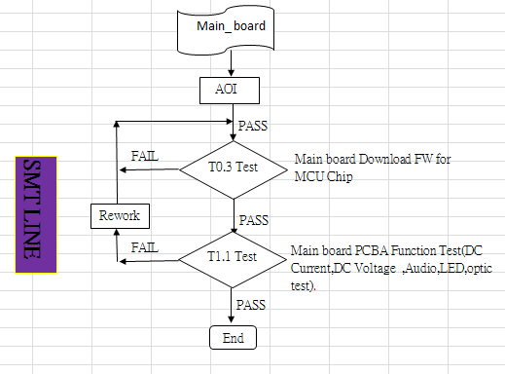

Audio_ Board Test Flow Chart
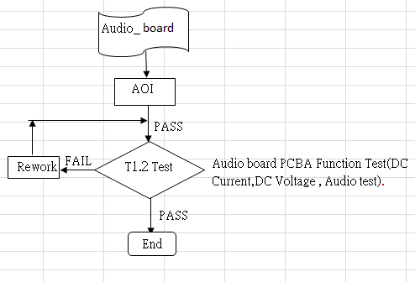

TOP Board Test Flow Chart

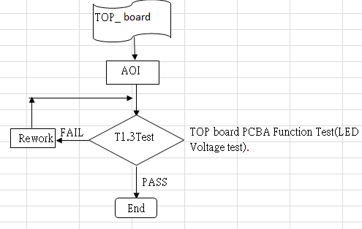

MIC FPC BOARD Test Flow Chart

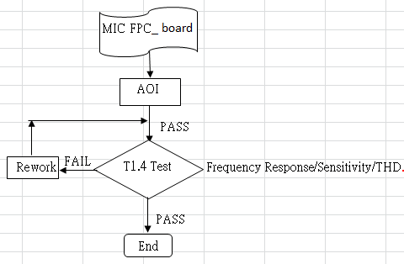

DC JACK BOARD Test Flow Chart

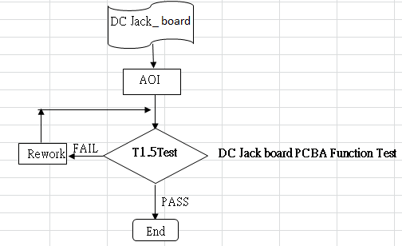

Assembly Test Flow Chart
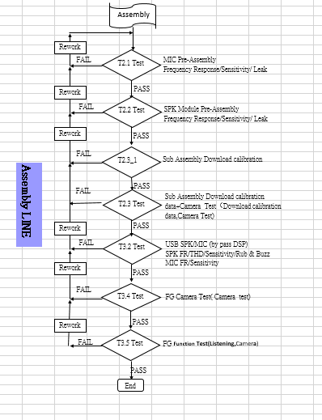

PACKING Test Flow Chart

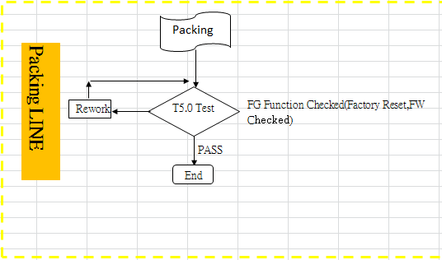

T0.1 Test Station→Download Firmware (Main board)

Programming of MCU(GD32F310G8U6)
Programming MCU is done by using T0.1 application from Merry and the T0.1 test fixture which provides connection from test points to GD Link Interface.
Burn FW to MCU(GD32F310G8U6)
List of HW(Test PC、Test instrument、Test fixture)
No. | Description |  | supplier | Cost
1. | PC(windows 10)
2. | USB to UART
3. | Test Fixture
List of SW (OS、Test Program)
No. | Description |  | Provider | Cost
1. | xxxxxxxxxxx
2. | MCU Download Program
Test Item/Test Condition & Limit
No. | Test Item | Condition | Min | Max
Download FW
1 | Scan SN | 1. TP4129 to 3.3V for MCU,TP4146(GND)  2. TP4154 MCU_BOOT0 pull high 3.3V-----(TP4129&TP4154 short）.  3. TP4144(UART_RX), TP4145(UART_TX)  4. Follow the SW update procedure to programming IC | PASS/FAIL
2 | Check_FW_Version |  | P1.20.00
3 | MCU_GD32F310_FW_Burn |  | PASS/FAIL
4 | FW_Burn_Check |  | PASS/FAIL
5 | CheckTestResult |  | PASS/FAIL

T0.3 test fixture block diagram and pictures
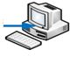
DUT
T0.3 Fixture Board

USB Cable

T1.1 Test Station → PCBA Electrical Function Test (MAIN BOARD)

PCBA Electrical Function Test
T1.1 station is used to test all PCBA functionalities including, power consumption, Electrical Test.
PCBA Function Test
List of HW(Test PC、Test instrument、Test fixture)
No. | Description |  | supplier |  | Cost
1. | PC(windows 7 SP2)
2. | T1.1 Test fixture
3. | GDM8342
4. | PPH-1503D
5. | USB Cable
List of SW (OS、Test Program)
No. | Description |  | supplier |  | Cost
1
Test Item/Test Condition & Limit
No. | Test Item | Condition | Min | Max |  | Unit
1 | Power On Current | 1.Set 12V to( TP1018) VCC_IN and GND(TP4125).  2. (Power On)?  3. Measure the Power current from PPH-1503D. | 11.64 | 12.36 |  | V
2 | VCC_PMIC(TP1019) | Measure the TP1019 voltage to GND. | 11.5 | 12.4 |  | V
3 | VDDD_CORE(TP108) | Measure the TP108 voltage to GND | 1.23 | 1.35 |  | V
4 | VDD_1V2(TP107) | Measure the TP107 voltage to GND | 1.285 | 1.35 |  | V
5 | VDD_0V6_VTT(TP106) | Measure the TP106 voltage to GND | 0.6 | 0.75 |  | V
6 | VDD_1V8(TP105) | Measure the TP105 voltage to GND | 1.71  -1 | 1.91  1 |  | V
7 | VDD_3V3(TP104) | Measure the TP104 voltage to GND | 3.135 | 3.45 |  | V
8 | VDD_2V8(TP704) | Measure the TP704 voltage to GND | 2.6 | 2.95 |  | V
9 | VDD_SEN_1V2(TP703) | Measure the TP703 voltage to GND | 1.4  0.5 | 1.62  1.2 |  | V
10 | VDD_SEN_1V8(TP4126) | Measure the TP4126 voltage to GND | 1.68  -1 | 1.9  1 |  | V
11 | PCBA Function Test(Video board) | Standy_Current | 105 | 135 |  | mA
12 | VDD_SEN_3V3_S(TP103) | Measure the TP103 voltage to GND | 3.0 | 3.65 |  | V
13 | TP4129_3V3_MCU | Measure the TP4129 voltage to GND | 3.0 | 3.65 |  | V
14 | TP4157_1V1_DFLT | Measure the TP4157 voltage to GND | 1.24 | 1 |  | V
15 | TP4159_1V2_DDRCK | Measure the TP4159 voltage to GND | 1.35 | 1.01 |  | V
16 | TP4122_VCC3IO_RTC | Measure the TP4122 voltage to GND | 3.55 | 3 |  | V
17 | TP4161_3V3_DFLT | Measure the TP4161 voltage to GND | 3.61 | 3 |  | V
18 | TP4158_1V8_DDRCK | Measure the TP4158 voltage to GND | 1.96 | 1.51 |  | V
19 | MCU_GD32F310_FW_Version | Check FW | V0.00.24 | V0.00.24 |  | PASS/FAIL
20 | Check_AST1220_FW_Version | Check FW | P1.20.00 | P1.20.00 |  | PASS/FAIL
21 | Check_KL520_FW_Version | Check FW | v6.5.20.NV12_192 | v6.5.20.NV12_192 |  | PASS/FAIL
22 | TP4162_Power_KEY |  | PASS/FAIL
23 | TP4163_MUTE_KEY |  | PASS/FAIL
24 | TP4164_VOL_UP_KEY |  | PASS/FAIL
25 | TP4165_VOL_DOWN_KEY |  | PASS/FAIL
26 | TP4166_Image_Mode_KEY |  | PASS/FAIL

T1.1 test fixture block diagram and pictures
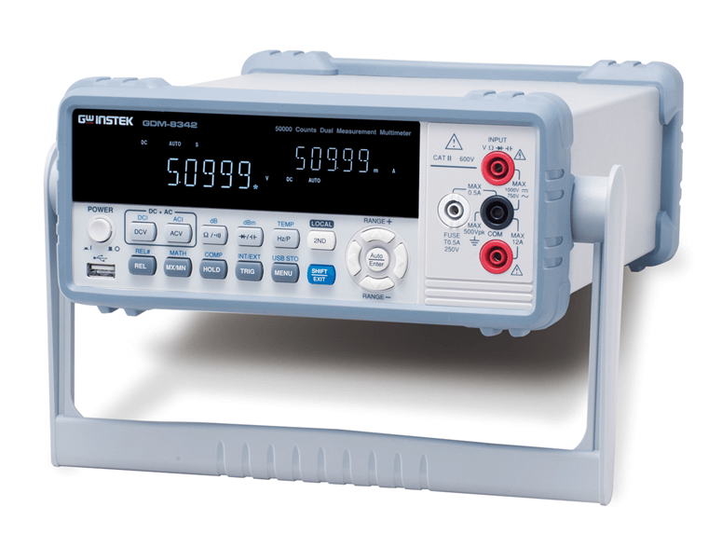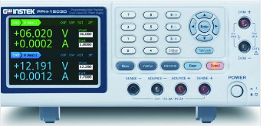
MAIN Board
DUT

T1.1 Test Fixture
USB Cable
Flat Cable
RS232

USB
GDM8342

T1.2 Test Station →(Audio_board Electrical Test)

Audio board PCBA Electrical Test
T1.2 station is used to test all PCBA functionalities including, power consumption, Electrical Test.
Audio board PCBA Electrical Test
List of HW(Test PC、Test instrument、Test fixture)
No. | Description |  | supplier |  | Cost
1. | PC(windows 7 SP2)
2. | T1.2 Test fixture
3. | GDM8342
4 | PPH-1503D
5. | USB Cable
List of SW (OS、Test Program)
No. | Description |  | supplier |  | Cost
1
Test Item/Test Condition & Limit
No. | Test Item | Condition | Min | Max |  | Unit
1 | Power On Current | 1.Set 12V to( TP1000) and GND(TP1004).  2. (Power On)?  3. Measure the Power current from PPH-1503D. | 11.64 | 12.36 |  | V
1 | Power On Current |  | 90 | 200 |  | mA
2 | 5V_VUSB(TP1002) | Measure the TP1002 voltage to GND | 4.5 | 5.7 |  | V
3 | 5V_BAT(TP5028) | Measure the TP5028 voltage to GND | 4.0 | 5.5 |  | V
4 | 3.3V_standby(TP1007) | Measure the TP1007 voltage to GND | 2.6 | 3.5 |  | V
5 | 1.5V_+1.8V_DDR(TP1009) | Measure the TP1009 voltage to GND | 1.3 | 1.99 |  | V
6 | CPU/+1.05V(TP1006) | Measure the TP1006 voltage to GND | 0.5 | 1.2 |  | V
7 | VDDC/1.05V(TP1010) | Measure the TP1010 voltage to GND | 0.5 | 1.2 |  | V
8 | VDDC/1.05V(TP2033) | Measure the TP2033 voltage to GND | 0.5 | 1.2 |  | V
9 | VDDIO_ +1.5V(TP2034) | Measure the TP2034 voltage to GND | 1.2 | 2.0 |  | V
10 | AVDD_PLL(TP2035) | Measure the TP2035 voltage to GND | 3.0 | 4.0 |  | V
11 | SPEAKER_TEST | 1. Connect a 8Ω resistor between speaker cable  2. In windows, Playt a signal with a frequency of 1KHZ tone(the windows volume need to set up to maxiumun ) and read the MT9050 volume setup register form DDR memory block.  To verify the DDR memory block.  3. Measure the 8Ω resistor AC voltage. | 0.8 | 1.3 |  | V
12 | MIC1 and SPEAKER loopbacktest | Refer to sheet "MIC and SPEAKER LOOPBACK TEST " | 3 | 9 |  | V
13 | MIC2 and SPEAKER loopbacktest | Refer to sheet "MIC and SPEAKER LOOPBACK TEST " | 3 | 9 |  | V
14 | Check FW Version | Read_MT9050_FW_Version | P1.17.0 | P1.17.0 |  | PASS/FAIL

T1.2 test fixture block diagram and pictures
Audio MAIN Board
DUT

T1.2 Test Fixture
USB Cable
Flat Cable
RS232

USB
GDM8342

T1.3 Test Station →( TOP Board Electrical Test)

TOP Board Electrical Test
T1.3 station is used to test all PCBA functionalities including, power consumption, LED Test.
TOP Board Electrical Test
List of HW(Test PC、Test instrument、Test fixture)
No. | Description |  | supplier |  | Cost
1. | PC(windows 7 SP2)
2. | T1.3 Test fixture
3. | GDM8342
4 | PPH-1503D
5. | USB Cable
List of SW (OS、Test Program)
No. | Description |  | supplier |  | Cost
1
Test Item/Test Condition & Limit
No. | Test Item | Condition | Min | Max |  | Unit
1 | Voltage measure | Measure MIC_DATA2 | 0 | 0.5 |  | V
2 | Voltage measure | Measure LED_3V | 3.2 | 3.4 |  | V
3 | LED Test | Measure 4_LED_On_Current | 40 | 60 |  | mA
4 | LED Test | Measure 8_LED_On_Current | 80 | 100 |  | mA
5

T1.3 test fixture block diagram and pictures
TOP Board DUT

T1.3 Test Fixture
USB Cable
Flat Cable
RS232

USB
GDM8342

T1.4 Test Station →( MIC FPC Board Test)

MIC FPC Board Test
MIC FPC Board Test
Hardware list (Testing Computer, Apparatus and Fixture etc. )
No. | Description |  | Supplier | Quantity
1. | Testing Computer |  |  | 1
2. | Test fixture |  |  | 1
3 | Mouth simulator (G.R.A.S 44AA ) |  |  | 1
4 | sound card |  |  | 1
5 | Digital analog conversion module(megasig U920) |  |  | 1
Software list (Operating system and Testing program)
No. | Description | Supplier |  | Quantity ns
1 | Windows10 |  |  | 1
2 | Soundcheck |  |  | 1

Test Item/Test Condition & Limit
No. | Test Item | Condition | Min | Max
1 | For Mic Frequency Response Frequency | Sine sweep 100Hz ~ 10KHz, input level:1Pa@sinewave | PASS/FAIL
2 | For MIC Sensitivity at 1kHz | Same as above | -29dB | -25 dB

T1.4 test fixture block diagram and pictures
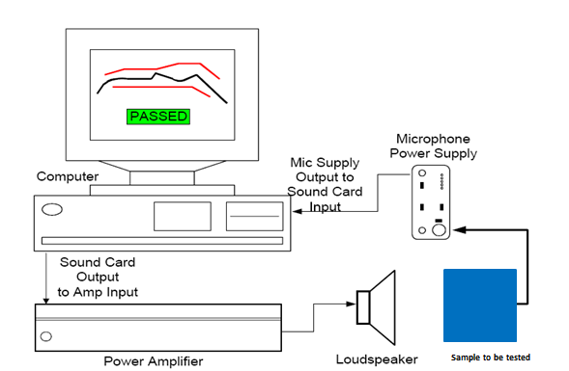

T1.5Test DC Jack board PCBA Function Test

DC Jack board PCBA Function Test
MIC FPC MIC Test
List of HW(Test PC、Test instrument、Test fixture)
No. | Description |  | supplier |  | Cost
1. | PC(windows 7 SP2)
2. | T1.3 Test fixture
3. | GDM8342
4. | PPH-1503D
5. | USB Cable
List of SW (OS、Test Program) |  |  |  |  |  | USB Cable
No. | Description |  | supplier |  | Cost
1 | TBD
Test Item/Test Condition & Limit
No. | Test Item | Condition | Min | Max |  | Unit
1 | 5V_VBUS(TP20) | Measure the TP20 voltage to GND | 4.5 | 5.5 |  | V
2 | DC_12V_CON(TP1) | Measure the TP1 voltage to GND | 11.64 | 12.36 |  | V
3

T1.5 test fixture block diagram and pictures
TOP Board DUT

T1.3 Test Fixture
USB Cable
Flat Cable
RS232

USB
GDM8342

T2.0 Test Station →( Speaker Pre-assy test)
Speaker Pre-assy test
Speaker Pre-assy test

Hardware list (Testing Computer, Apparatus and Fixture etc. )
No. | Description |  | Supplier | Quantity
1. | Testing Computer |  |  | 1
2. | Test fixture |  |  | 1
3 | CD14422 Measurement Mic |  |  | 1
4 | sound card |  |  | 1
5 | Amplifier |  |  | 1
Software list (Operating system and Testing program)
No. | Description | Supplier |  | Quantity ns
1 | Windows10 |  |  | 1
2 | Soundcheck |  |  | 1

Test Item/Test Condition & Limit
No. | Test Item | Condition | Min | Max
1 | Frequency Response | Sine sweep 20 Hz ~ 20k Hz,  input level:2.83mVrms@sinewave ;ISO R20 | PASS/FAIL
2 | Sensitivity at 1kHz | Same as above | 111dB | 115dB
3 | THD | Same as above | - | 3%
4 | Rub&buzz | Same as above | - | 2%

T2.1 test fixture block diagram and pictures
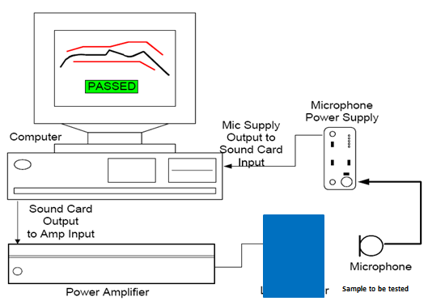

T2.1 Test Station →( MIC Curve test)

MIC Curve test
MIC Curve test
Hardware list (Testing Computer, Apparatus and Fixture etc. )
No. | Description |  | Supplier | Quantity
1. | Testing Computer |  |  | 1
2. | Test fixture |  |  | 1
3 | Mouth simulator (G.R.A.S 44AA ) |  |  | 1
4 | sound card |  |  | 1
5 | Digital analog conversion module(megasig U920) |  |  | 1
Software list (Operating system and Testing program)
No. | Description | Supplier |  | Quantity ns
1 | Windows10 |  |  | 1
2 | Soundcheck |  |  | 1

Test Item/Test Condition & Limit
No. | Test Item | Condition | Min | Max
1 | Mic1&MIC2&MIC3&MIC4 Frequency Response Frequency | Sine sweep 100Hz ~ 10KHz, input level:1Pa@sinewave | PASS/FAIL
2 | Mic1&MIC2&MIC3&MIC4 Sensitivity at 1kHz | Same as above | -29dB | -25dB
3 | Mic1&MIC2&MIC3&MIC4 Seal test | Same as above | PASS/FAIL

T2.1 test fixture block diagram and pictures

T2.2 Test Station →( MIC Sealing test)

MIC Sealing test
MIC Sealing test
Hardware list (Testing Computer, Apparatus and Fixture etc. )
No. | Description |  | Supplier | Quantity
1. | Testing Computer |  |  | 1
2. | Test fixture |  |  | 1
3 | Mouth simulator (G.R.A.S 44AA ) |  |  | 1
4 | sound card |  |  | 1
5 | Digital analog conversion module(megasig U920) |  |  | 1
Software list (Operating system and Testing program)
No. | Description | Supplier |  | Quantity ns
1 | Windows10 |  |  | 1
2 | Soundcheck |  |  | 1

Test Item/Test Condition & Limit
No. | Test Item | Condition | Min | Max
1 | Mic1&MIC2&MIC3&MIC4 Frequency Response Frequency | Sine sweep 100Hz ~ 10KHz, input level:1Pa@sinewave | PASS/FAIL
2 | Mic1&MIC2&MIC3&MIC4 Sensitivity at 1kHz | Same as above | -45dB | -120dB
3 | Mic1&MIC2&MIC3&MIC4 Seal test | Same as above | PASS/FAIL

T2.2 test fixture block diagram and pictures

T2.3 Test Station →( Sub Assembly Camera Test)

Sub Assembly Camera Test
Camera Test
List of HW(Test PC、Test instrument、Test fixture)
No. | description |  |  | supplier |  | Cost
1. | PC(windows 7 SP2)
2. | Sub Assembly camera fixture
3. | TBD
4. | TBD
5. | TBD
List of SW (OS、Test Program)
No. | Describtion |  |  | Provider |  | Cost
1
2 | T2.3 Test Program
Test Item/Test Condition & Limit
No. | Test Item | Condition | Min |  | Max |  | Unit
1 | Power On | - Power supply (Set DC12V to DUT).  - Power On. | PASS/FAIL |  | PASS/FAIL |  | PASS/FAIL
2 | Scanning SN | Scan FG SN | NA |  | NA |  | NA
3 | Check_Test_Flag | Check the test results of previous operation from MES system | 02 |  | 02 |  | PASS/FAIL
4 | Check_AST1220_FW_Version | Read FW(AST1220) version information. | P1.23.00 |  | P1.23.00 |  | PASS/FAIL
5 | Check_KL520_FW_Version | Read FW(KL520) version information. | v6.6.21.NV12_192 |  | v6.6.21.NV12_192 |  | PASS/FAIL
6 | Check_MT9050_FW_Version | Read FW(MT9050) version information. | P1.23.00 |  | P1.23.00 |  | PASS/FAIL
7 | SFR@1.2m_Cam0_Img_Center | Analysis of camera picture calculation | 0.54 |  | 1.2
8 | SFR@1.2m_Cam0_Img_TL | Analysis of camera picture calculation | 0.23 |  | 1
9 | SFR@1.2m_Cam0_Img_TR | Analysis of camera picture calculation | 0.23 |  | 1
10 | SFR@1.2m_Cam0_Img_BL | Analysis of camera picture calculation | 0.23 |  | 1
11 | SFR@1.2m_Cam0_Img_BR | Analysis of camera picture calculation | 0.23 |  | 1
12 | SFR@0.7m_Cam1 | Analysis of camera picture calculation | 0.52 |  | 1
13 | Shading_Cam4 | Analysis of camera picture calculation | 0.75 |  | 1.15
14 | SFR@1.2m_Cam3_Img_Center | Analysis of camera picture calculation | 0.54 |  | 1.2
15 | SFR@1.2m_Cam3_Img_TL | Analysis of camera picture calculation | 0.23 |  | 1
16 | SFR@1.2m_Cam3_Img_TR | Analysis of camera picture calculation | 0.23 |  | 1
17 | SFR@1.2m_Cam3_Img_BL | Analysis of camera picture calculation | 0.23 |  | 1
18 | SFR@1.2m_Cam3_Img_BR | Analysis of camera picture calculation | 0.23 |  | 1
19 | SFR@0.7m_Cam0 | Analysis of camera picture calculation | 0.52 |  | 1
20 | Shading_Cam1 | Analysis of camera picture calculation | 0.75 |  | 1.15
21 | SFR@1.2m_Cam4_Img_Center | Analysis of camera picture calculation | 0.54 |  | 1.2
22 | SFR@1.2m_Cam4_Img_TL | Analysis of camera picture calculation | 0.23 |  | 1
23 | SFR@1.2m_Cam4_Img_TR | Analysis of camera picture calculation | 0.23 |  | 1
24 | SFR@1.2m_Cam4_Img_BL | Analysis of camera picture calculation | 0.23 |  | 1
25 | SFR@1.2m_Cam4_Img_BR | Analysis of camera picture calculation | 0.23 |  | 1
26 | SFR@0.7m_Cam3 | Analysis of camera picture calculation | 0.52 |  | 1
27 | Shading_Cam0 | Analysis of camera picture calculation | 0.75 |  | 1.15
28 | SFR@1.2m_Cam1_Img_Center | Analysis of camera picture calculation | 0.54 |  | 1.2
29 | SFR@1.2m_Cam1_Img_TL | Analysis of camera picture calculation | 0.23 |  | 1
30 | SFR@1.2m_Cam1_Img_TR | Analysis of camera picture calculation | 0.23 |  | 1
31 | SFR@1.2m_Cam1_Img_BL | Analysis of camera picture calculation | 0.23 |  | 1
32 | SFR@1.2m_Cam1_Img_BR | Analysis of camera picture calculation | 0.23 |  | 1
33 | SFR@0.7m_Cam4 | Analysis of camera picture calculation | 0.52 |  | 1
34 | Shading_Cam3 | Analysis of camera picture calculation | 0.75 |  | 1.15
35 | Stitching_Defect_Test | Analysis of camera picture calculation | -5 |  | 5
36 | Write_Test_Flag | Write_Test_Flag | PASS/FAIL |  | PASS/FAIL |  | PASS/FAIL

T2.3 test fixture block diagram and pictures
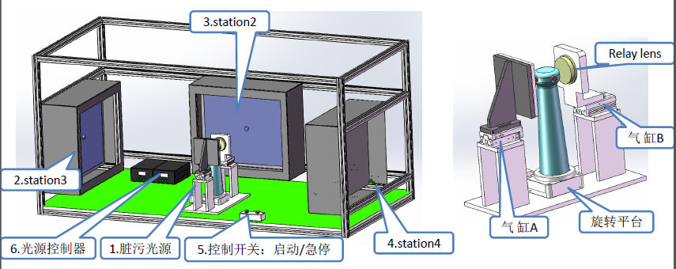

T2.3-1 Test Station →( Sub Assembly Download calibration data)

Sub Assembly Download calibration data
Download calibration data
List of HW(Test PC、Test instrument、Test fixture)
No. | description |  |  | supplier |  | Cost
1. | PC(windows 7 SP2)
2.
3.
4.
5.
List of SW (OS、Test Program)
No. | Describtion |  |  | Provider |  | Cost
1
2 | T2.3-1 Test Program
Test Item/Test Condition & Limit
No. | Test Item | Condition | Min |  | Max |  | Unit
1 | Download calibration data | TBD | PASS/FAIL |  | PASS/FAIL |  | PASS/FAIL
2
3
4

T2.3-1 test fixture block diagram and pictures

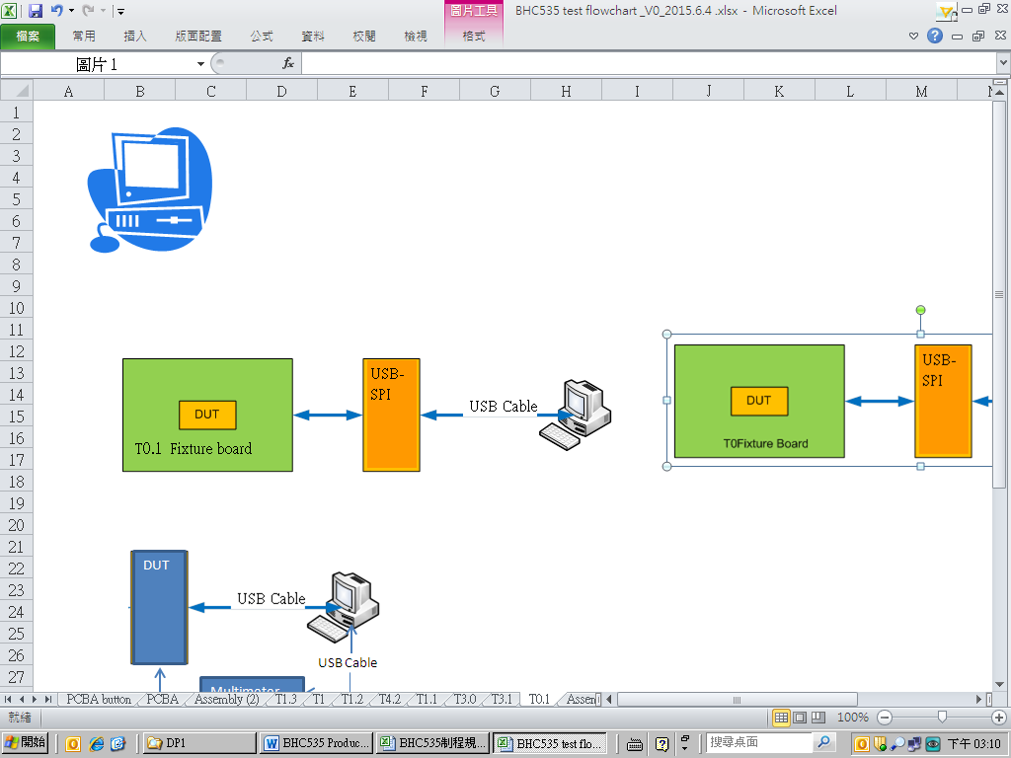
T2.3-1 Test Station

T3.2 Test Station→( Acoustic test of finished products)

Acoustic test of finished products
Acoustic test of finished products
Hardware list (Testing Computer, Apparatus and Fixture etc. )
No. | Description |  |  | Supplier |  | Quantity
1. | Testing Computer |  |  |  |  | 1
2. | Test fixture |  |  |  |  | 1
3 | CD14422 Measurement Mic |  |  |  |  | 1
4 | Mouth simulator (G.R.A.S 44AA ) |  |  |  |  | 1
5 | Microphone power |  |  |  |  | 1
6 | sound card |  |  |  |  | 1
Software list (Operating system and Testing program)
No. | Description |  | Supplier |  |  | Quantity ns
1 | Windows10 |  |  |  |  | 1
2 | Soundcheck |  |  |  |  | 1
Testing items, Testing condition and Limit
N | Items | Condition | Min |  |  | Max
1 | SPK Frequency Response | Sine sweep 50Hz ~ 20KHz,  input level:-3dBFS@sinewave；ISO R20 | PASS/FAIL
2 | SPK Sensitivity at 1kHz | Same as above. | 77dB |  | 83dB
3 | SPK THD | Same as above. | PASS/FAIL
4 | SPK RUB&BUZZ | Same as above. | - |  | 2%
5 | Mic Frequency Response Frequency | Sine sweep 100Hz ~ 10KHz, input level:1Pa@sinewave | 5% |  | 15%
6 | Mic Sensitivity at 1kHz | Same as above. | -33dB |  | -25dB

T3.2 test fixture block diagram and pictures
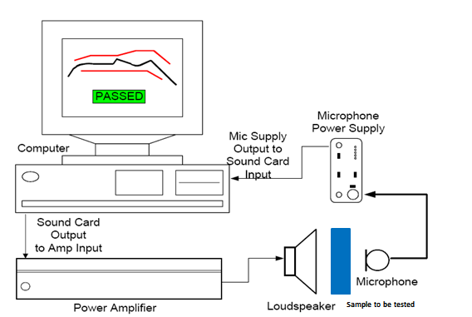

T3.4Test Station→( FG Camera Test)

FG Camera Test
FG Camera Test
Hardware list (Testing Computer, Apparatus and Fixture etc. )
No. |  | Description |  |  | Supplier |  |  | Quantity
1. |  | Testing Computer |  |  |  |  |  | 1
2. |  | Camera test fixture |  |  |  |  |  | 1
3

4
5
Software list (Operating system and Testing program)
No. |  | Description |  | Supplier |  |  |  | Quantity ns
1 |  | Windows7 |  |  |  |  |  | 1
 |  | TBD
Testing items, Testing condition and Limit
No. | Test Item |  | Condition |  |  | Min | Max |  | Unit
1 | Power On |  | 1.Power supply (Set DC12V to DUT).  2.Power On. |  |  | PASS/FAIL | PASS/FAIL |  | PASS/FAIL
2 | Scanning SN |  | Scan FG SN |  |  | NA | NA |  | NA
3 | Check_Test_Flag |  | Check the test results of previous operation from MES system |  |  | 04 | 04 |  | PASS/FAIL
4 | Check_AST1220_FW_Version |  | Check_AST1220_FW_Version |  |  | P1.23.00 | P1.23.00 |  | PASS/FAIL
5 | Check_KL520_FW_Version |  | Check_KL520_FW_Version |  |  | v6.6.21.NV12_192 | v6.6.21.NV12_192 |  | PASS/FAIL
6 | Check_MT9050_FW_Version |  | Check_MT9050_FW_Version |  |  | P1.23.00 | P1.23.00 |  | PASS/FAIL
7 | Check_MCU_FW_Version |  | Check_MCU_FW_Version |  |  | V0.00.26 | V0.00.26 |  | PASS/FAIL
8 | SFR_Cam0_MTF50 |  | Analysis of camera picture calculation |  |  | 0.2
9 | SFR_Cam0_MTF30 |  | Analysis of camera picture calculation |  |  | 0.3
10 | MCC_Cam0 |  | Analysis of camera picture calculation |  |  |  | 20
11 | LSC_Cam0 |  | Analysis of camera picture calculation |  |  | 0.75
12 | SFR_Cam1_MTF50 |  | Analysis of camera picture calculation |  |  | 0.2
13 | SFR_Cam1_MTF30 |  | Analysis of camera picture calculation |  |  | 0.3
14 | MCC_Cam1 |  | Analysis of camera picture calculation |  |  |  | 20
15 | LSC_Cam1 |  | Analysis of camera picture calculation |  |  | 0.75
16 | SFR_Cam2_MTF50 |  | Analysis of camera picture calculation |  |  | 0.2
17 | SFR_Cam2_MTF30 |  | Analysis of camera picture calculation |  |  | 0.3
18 | MCC_Cam2 |  | Analysis of camera picture calculation |  |  |  | 20
19 | LSC_Cam2 |  | Analysis of camera picture calculation |  |  | 0.75
20 | SFR_Cam3_MTF50 |  | Analysis of camera picture calculation |  |  | 0.2
21 | SFR_Cam3_MTF30 |  | Analysis of camera picture calculation |  |  | 0.3
22 | MCC_Cam3 |  | Analysis of camera picture calculation |  |  |  | 20
23 | LSC_Cam3 |  | Analysis of camera picture calculation |  |  | 0.75
24 | Stitching_Test |  | Analysis of camera picture calculation |  |  | -8 | 8
25 | Write_Test_Flag |  | Write_Test_Flag |  |  | PASS/FAIL | PASS/FAIL |  | PASS/FAIL

T3.4 test fixture block diagram and pictures

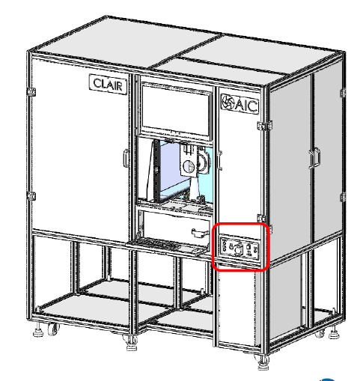

T3.5 Test Station (FG Function Test(Listening,Camera) )

FG Listening,Camera Test
No. |  | Description |  |  | Supplier |  | Quantity
1. |  | Testing Computer |  |  |  |  | 1
2. |  | Camera test fixture |  |  |  |  | 1
3 |  | GDM8342 |  |  |  |  | 1
4
5
Software list (Operating system and Testing program)
No. |  | Description |  | Supplier |  |  | Quantity ns
1 |  | Windows7 |  |  |  |  | 1
 |  | TBD
No. | Test Item |  | Condition | Min |  | Max |  | Unit
1 | Scanning SN |  | Scan FG SN | NA |  | NA |  | NA
2 | OffModel_Current5 |  | OffModel_Current | 6 |  | 10 |  | mA
3 | Check_Test_Flag |  | Check the test results of previous operation from MES system | 05 |  | 05 |  | PASS/FAIL
4 | Read_SN |  | Read FG SN | PASS/FAIL |  | PASS/FAIL |  | PASS/FAIL
5 | Check_SN |  | Check FG SN | PASS/FAIL |  | PASS/FAIL |  | PASS/FAIL
6 | Camera_Test |  | Test check the camera picture | PASS/FAIL |  | PASS/FAIL |  | PASS/FAIL
7 | A2DP_Test |  | Listening test | PASS/FAIL |  | PASS/FAIL |  | PASS/FAIL
8 | HFP_Test |  | Records test | PASS/FAIL |  | PASS/FAIL |  | PASS/FAIL
9 | Write_Test_Flag |  | Write Test Flag | PASS/FAIL |  | PASS/FAIL |  | PASS/FAIL

T3.5 test fixture block diagram and pictures

T5.0 Test Station (FG Function Checked(Factory Reset,FW Checked)

FG Listening,Camera Test
No. |  | Description |  |  | Supplier |  | Quantity
1. |  | Testing Computer |  |  |  |  | 1
2. |  | Camera test fixture |  |  |  |  | 1
3

4
5
Software list (Operating system and Testing program)
No. |  | Description |  | Supplier |  |  | Quantity ns
1 |  | Windows7 |  |  |  |  | 1
 |  | TBD
No. | Test Item |  | Condition | Min |  | Max |  | Unit
1 | Scanning SN |  | Scan FG SN | NA |  | NA |  | NA
2 | Check_Test_Flag |  | Check the test results of previous operation from MES system | 06 |  | 06 |  | PASS/FAIL
3 | Check_AST1220_FW_Version |  | Check_AST1220_FW_Version | P1.23.00 |  | P1.23.00 |  | PASS/FAIL
4 | Check_KL520_FW_Version |  | Check_KL520_FW_Version | v6.6.21.NV12_192 |  | v6.6.21.NV12_192 |  | PASS/FAIL
5 | Check_MT9050_FW_Version |  | Check_MT9050_FW_Version | P1.23.00 |  | P1.23.00 |  | PASS/FAIL
6 | Check_MCU_FW_Version |  | Check_MCU_FW_Version | V0.00.26 |  | V0.00.26 |  | PASS/FAIL
7 | Factory Reset |  | Factory Reset | PASS/FAIL |  | PASS/FAIL |  | PASS/FAIL
8  目錄  鍵入章節標題 (第 1 層) 1  鍵入章節標題 (第 2 層) 2  鍵入章節標題 (第 3 層) 3  鍵入章節標題 (第 1 層) 4  鍵入章節標題 (第 2 層) 5  鍵入章節標題 (第 3 層) 6  目錄  鍵入章節標題 (第 1 層) 1  鍵入章節標題 (第 2 層) 2  鍵入章節標題 (第 3 層) 3  鍵入章節標題 (第 1 層) 4  鍵入章節標題 (第 2 層) 5  鍵入章節標題 (第 3 層) 6 | Write_Test_Flag |  | Write Test Flag | PASS/FAIL |  | PASS/FAIL |  | PASS/FAIL

T5.0 test fixture block diagram and pictures

